[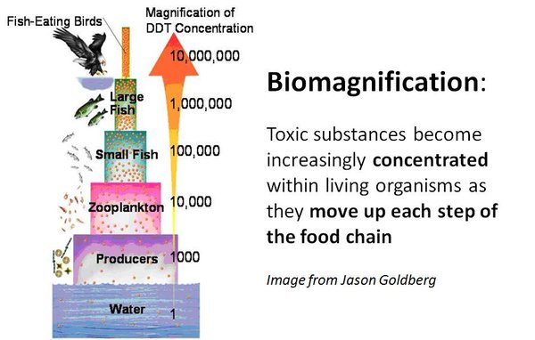](https://www.google.com.au/url?sa=i&rct=j&q=&esrc=s&frm=1&source=imgres&cd=&cad=rja&uact=8&ved=0ahUKEwjkmZDLms_PAhWFnJQKHRxBASoQjRwIBw&url=https%3A%2F%2Ftwitter.com%2Fhashtag%2Fbiomagnification&psig=AFQjCNG3IgzmB_-j5sCehg2ckuxuRPasBg&ust=1476153536571634)